Nick Forleo

Lesson 2 Homework: Use Case Analysis

1. Actors

| **Type** | **Actor** | **Goal Description** |
| --- | --- | --- |
| Primary | Customer | Uses the system to make a rental car reservation |
|  | Car Rental Service Representative | Uses the system to manage reservations and interact with the customer |
| Supporting | Payment Vendor | Manages payments and/or refunds |
|  | System Admin | Manually make changes to system information in case of erroneous usage |
|  | Insurance Representative | Sell insurance policies on the rental vehicles to the customers or handle insurance claims |
|  | Customer Service Team | Assist the customer to complete a goal within the system |
|  | Legal | Verify customer adheres to company policies and laws |
| Offstage | Accounting Firm | Utilize data generated by users of the system assist with tax related services |
|  | Police Departments | Utilize data generated by users or the company to assist with investigations |
|  | Business Review Sites | Customer experience with the system can help form what review sites will write about the company |

1. Use Cases
2. Create a reservation. (Customer, Car Rental Service Representative)
3. Cancel a reservation. (Customer, Car Rental Service Representative)
4. Collect payment. (Payment Vendor)
5. Issue refund. (Payment Vendor)
6. Insure customer. (Insurance Representative)
7. Modify data. (System Admin)
8. Assist customer. (Customer Service Team, customer)
9. Verify customer eligibility. (Legal, Customer)

3. Use Case Diagram

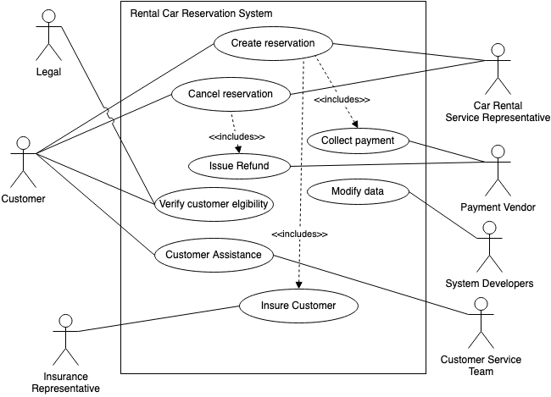

4. Partially-Dressed UC

**Use Case Name:** Create reservation for rental car

**Goal in Context:** A customer can create a reservation for a rental car using the system.

**Primary Actors:** Customer

**Scenario:**

1. Customer requests a reservation for a rental car and provides data relevant to the reservation.
2. Customer enters necessary personal information.
3. Legal verifies the customer is eligible to rent a car.
4. Customer selects relevant insurance policies.
5. Insurance representative underwrites the customer.
6. Customer confirms reservations and the car rental reservation system approves the reservation.
7. Payment vendor collects money once the reservation is complete.

5. System Sequence Diagram (SSD)

